**The CSS Box Model**

The CSS box model represents each element on a web page as a box with four sides: content, padding, border, and margin. These components determine the size and spacing of elements.

**Components:**

1. **Content:** The area containing the element's content (text, images, etc.).
2. **Padding:** The space between the content and the border.
3. **Border:** The outline surrounding the element.
4. **Margin:** The space outside the border, separating the element from other elements.

**Example HTML Structure:**

HTML

<!DOCTYPE html>

<html>

<head>

<title>Box Model Example</title>

<style>

.box {

width: 200px;

height: 100px;

border: 2px solid black;

padding: 10px;

margin: 20px;

}

</style>

</head>

<body>

<div class="box">This is a box</div>

</body>

</html>

**Visual Representation:**

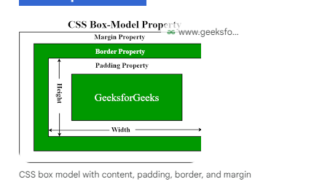

**Explanation:**

* The .box class defines a container with a width of 200px, a height of 100px, a 2px solid black border, 10px of padding, and a 20px margin.
* The content of the box is "This is a box."
* The padding creates space between the content and the border.
* The border outlines the box.
* The margin creates space between the box and other elements on the page.

**Modifying the Box Model:**

You can adjust the layout and spacing of elements by modifying the values of the padding, border, and margin properties.

* **Padding:** Increases or decreases the space between the content and the border.
* **Border:** Changes the width, style, and color of the border.
* **Margin:** Controls the space between the element and other elements.